**DEPARTMENT OF PROSTHODONTICS**

**SATHYABAMA DENTAL COLLEGE AND HOSPITAL**

**CASE RECORD**

PT. NAME : DATE:

AGE/SEX : O.P NO. :

ADDRESS : MEDICAL ALERT :

OCCUPATION :

PHONE NO. :

CHIEF COMPLAINT :

MEDICAL HISTORY :

Hypertensive / Diabetes / Cardiac Problems / others

If Yes, details of the medication :

Allergies if any :

DENTAL HISTORY :

EXTRA0RAL EXAMINATION:

TMJ :

INTRAORAL EXAMINATION: 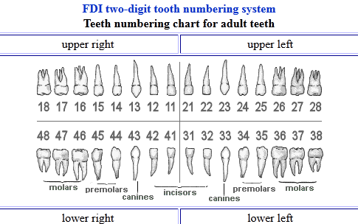

TEETH FILLED:

TEETH MISSING :

ROOT TREATED:

OCCLUSION:

CANINE: MOLAR: OTHERS:

MISCELLANEOUS:

RADIOGRAPHIC INTERPRETATION :

DIAGNOSIS:

TREATMENT PLAN:

|  |  |
| --- | --- |
| REMOVABLE PARTIAL DENTURE |  |
| COMPLETE DENTURE |  |
| FIXED PARTIAL DENTURE |  |
| IMPLANT |  |
| OTHERS |  |

PAYMENT AMOUNT : RECEIPT NUMBER: